Last Updated: 4/22/2019
This Quick Reference Guide (QRG) is intended to assist Executive Reviewers in Importing Merit Increase data within the Compensation module of SuccessFactors.
This QRG is a part of the Annual Merit Allocation Business Process and the Merit Planning for Executive Reviewers QRG.

There are important considerations and cautions related to importing data.
Please read the instructions below thoroughly.
Contents
Considerations and Cautions 1
Import Merit Worksheet 2

Considerations and Cautions
1. Only import the records of individuals for which data has been changed and you are sure that no other Executive Reviewer or Compensation Manager has edited in the system since you exported the data. It is very possible to overwrite other data via the import process.
  - Example:
    - On Monday, the Executive Reviewer exports a file containing the data of Compensation Manager A, Compensation Manager B, and Compensation Manager C.
    - On Tuesday, Compensation Manager B completes the Merit Planning process in the module.
    - On Thursday, the Executive Reviewer imports the file previously exported, which will overwrite all data for all individuals in the file. This will zero-out all of the changes input by Compensation Manager B.
- The following columns can be exported, edited, and imported (by Executive Reviewers only):
  - Merit Increase, Equity Increase, Extra Merit, Administrative Adjustment, and Comments
- Changes to the yellow columns will not change non-highlighted columns, but will update when imported. (e.g. if the Merit increase in dollars is increased, the Merit increase in percent will not change).
- Do not delete or change Column A
- Do not delete or change Row 1 or Row 2
- In the Merit Increase column, a dollar amount ($) must be entered, not a percentage
- The workbook cannot be imported with formulas
  - If you create formulas in the worksheet, the resulting Values must be copied and pasted as values into the fields, removing the formulas.
  - 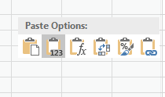
- The workbook cannot be imported with any missing or extra columns.

Import Merit Worksheet
After Exporting the worksheet and editing data, use these steps to Import the worksheet.
- For instructions on exporting data, see the Merit Planning for Executive Reviewers QRG.
Click Executive Review
Click Import at the bottom of the worksheet |  | 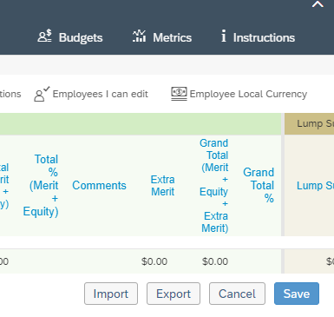
Click Choose File to select the file to be imported.  Mark the checkboxes to send any desired notifications to the Compensation Manager and/or One-up Compensation Manager.  Click Import  The import may take several minutes.  You will receive an email notification when the import is complete. Please review the message to check for any import errors. Common errors messages and resolutions are found below. |  | 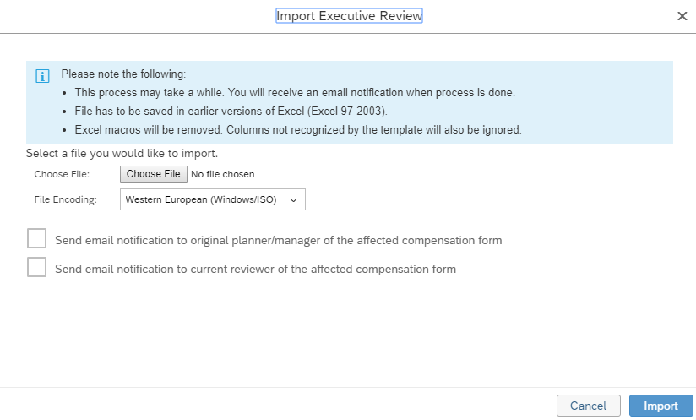
- You will receive a confirmation email. Review the email to check for import errors.
- Revisit the worksheet and/or refresh the browser to view the imported changes.
- The Compensation Manager and One-Up Compensation Manager will receive an email notification listing the individuals whose merit increase information was updated and by whom.
Error Message | Meaning/Steps to Resolve
Guideline Hard Violation encountered for <merit> | You attempted to import a merit increase for an individual that placed them outside of the Salary Band. Move the excess to Lump Sum, Extra Merit, or Equity Increase.  Note: When the program encounters this type of error, it will not process any other records below this line in the file.
Process Error: plan has hard violation field(s)! | Record was not processed due to another record creating an error. (See description above)

